**Assessment type (🗹):**

☐ Questioning (Oral/Written)

☐ Practical Demonstration

☐ 3rd Party Report

☒ Other – Project/Portfolio (*Part of assessment task 1)*

**Assessment Resources:**

|  |
| --- |
| * PC * Google * Computer components PowerPoint |

**Assessment Instructions:**

|  |
| --- |
| Instructions to the assessor:  This lab is a part of Assessment Task 2 portfolio, it is a practical lab based on the performance criteria requirements of the unit. Each student should be given a copy of this lab to complete either in class or out of class. As the student completes each section of this lab you should verify, check off and sign off the section (Use this document as the observation checklist). Use the assessor section at the bottom to provide feedback to the student if required.  See the instructions to the student section for the remainder of the instructions.  Instructions to the student:  This lab consists of activities that you perform on the hardware and software nominated concerning preventative maintenance and base level troubleshooting procedures.  There are several short answer questions where you will be asked to research and answer questions relating to these topics. You are encouraged to use the documentation in the resource section to help you work on the requirements.  Time:  Nominally 120 mins  Due date:  This lab is part of assessment 1 and inherits its due date.  Submission instructions:  When the lab is complete, submit the assessment via Blackboard.  Reasonable adjustment:  Should there be difficulty with reading technical manuals relating to disability of language and literacy levels you are encouraged to use online video tutorials similar to the following:   * https://www.youtube.com/watch?v=HBP8_LqBj44   The lab can be delivered in combination with support software like “Cortana” to help verbalise the tasks. Tasks may also be re-phrased by the assessor if required. If there are issues with resources (e.g. Blackboard/Routers) the lab can be modified to suit assuming it does not compromise its original intent. |

|  |  |
| --- | --- |
| Your Student ID: | Your Name: |

**Section 1: Software Maintenance**

**Open your Win 11 Pro VM**

1. **Windows Updates**
   1. The Windows 11 installation process twice included online update steps. Despite this, the final installed versions may still require additional updates.
   2. Right-click on the ***Start*** Button and select ***Device Manager***.  
      The *Device Manager* utility is about the Driver Software used by each of the virtual PC hardware components.  
      Ideally there should be no red crosses or explanation marks (!) for any of the hardware components. But after the initial installation, it is common for there to be some Driver software issues to resolve.   
        
      **Note:** Microsoft will generally install **generic** device drivers which will do the basic job of allowing communications between the Windows OS and the firmware in each component. For some components, especially for installed graphics cards downloading and installing the **Vendor’s** (manufacturer) drivers and utility software will improve the performance and utilize all the features of the device. The Windows Updater usually will not search for the Vendor drivers.

|  |
| --- |
| Take **Snip1** of the **Device Manager results**, expanding out any issues. PASTE HERE! |

* 1. In the ***Quick Seach*** space to the right of the ***Start*** button, type ***update*** and press Enter to select ***Check for Updates***
     1. Turn the ***Get the latest updates as soon as they’re available.***
     2. Click **On** the ***Advanced options***
     3. Click **On** the *Receive updates for other Microsoft products*.  
        Note the *Additional options* for future reference.
     4. Go back to the *Windows Update* and click on the ***Check for updates*** button

|  |
| --- |
| Once listed, take **Snip2** of the **available updates** and paste here. |

**Notes, please read:**i. The complete update process can take well over an hour, so while you can start the update process, **after 10 minutes**, **restart** your Win 11 VM to complete whatever is ready and complete the rest of the updates when you have time. E.g. running Updates while doing another class task. **Read** the remaining notes below.

|  |
| --- |
| After completing your updates, take **Snip3** of the ***Update history*** and paste here. |

ii. Each update item will have several statuses

* + Downloading: (many items can be downloading simultaneously)
  + Install: (you will need to click on this button for this item to install)
  + Installing: (only one item can be installing at any one time, i.e. sequentially)
  + Completed: (no further action is required, but may not take effect until after a Restart)
  + Retry: (Do not attempt to retry until after a restart. Sometimes after a day or two the item will no longer be listed)
  + Restart: These items require additional processes during the restart – up to 30% then another automatic restart up to 100%. If several updates require a restart, then these will be done sequentially.

iii. After each restart, *check the updates* to see if more updates are available. This should be done until the app reports *You’re* ***Up-to-date***.  
  
iv. If issues with Drivers or components remain, go to the ***Advanced Options*** and check the contents of ***Optional updates***. Generally, only download and install if there is a need for a specific optional update.

|  |
| --- |
| IF you had some Driver issues in Step 1b, open ***Device Manager*** again, take **Snip4** and paste here. |

v. An additional Microsoft tool is the command line utility **winget**   
Open the **CMD window as an Administrator**.  
Type **winget upgrade**

|  |
| --- |
| Insert **Snip 5** of all available package updates listed |

vi. Now Upgrade these packages using **winget upgrade –all**

|  |
| --- |
| Insert **Snip6** of the final few updated packages |

vii. There are many third party (not from Microsoft) update apps including driver update apps available. I would only recommend updaters from the Vendor’s Web site or from PC or laptop manufacturer.

1. **Windows Maintenance Tools**

The installed Windows OS comes with several maintenance utility apps.  
These can be addressed individually from the ***Start*** Menu, or running a command from the ***Command Prompt*** app. Also, Windows has several portal apps through which you can access several maintenance utilities.

1. Open ***File Explorer*** > ***This PC***
2. Right-click on ***Windows C:*** > Select ***Properties*** > Select ***Tools*** tab.  
   There are two Maintenance Utilities, ***Error checking*** and ***Optimize***.
3. The Error checking utility has a blue &Yellow shield next to it.

|  |
| --- |
| What does the blue & yellow shield indicate?  The software will always require administrator rights to run, as indicated by the yellow and blue shield icon.  What type of disk errors does this utility detect and correct?  File system issues can be found and fixed via error checking.  What is the equivalent **Command Prompt** Instruction for Error checking?  Chkdsk is the command prompt command for error checking. |

1. The operation of the Optimize utility depends on whether the Disk drive is a
   1. Solid State Drive SSD

|  |
| --- |
| Explain what Trimming (Optimizing) the SSD does.  manage unused data blocks, Informs the SSD about deleted data, Improves write performance |

* 1. Hard Disk Drive

|  |
| --- |
| Explain what Analysing and Defragging the HDD does. Defragmenting a hard drive (HDD) entails moving files around the disk so they are stored in consecutive blocks, which enhances system speed. The defragmentation procedure reorganizes the data for quicker access after the drive's level of fragmentation is assessed.  Why does defragging not apply to SDDs?  Since Solid State Drives (SSDs) do not suffer from the same file fragmentation-related performance problems as Hard Disk Drives (HDDs), defragmenting is neither required nor advantageous. |

* 1. Run both tools.

1. Open **administrative tools** on Windows 11
   1. Open the ***Run*** command.
   2. Type in the command ***control admintools***  
      Note the pathway from the ***Control Panel*** to these tools.

|  |
| --- |
| Hide the preview pane, expand so that most of the tool icons are showing, take **Snip7** of the **pathway window and tools** and paste here. |

1. Run **System Maintenance Troubleshooter (MS Support Diagnostic Tool, MSDT)**
   1. to run the System Maintenance Troubleshooter. Open ***Run***, type the following and hit Enter:
   2. *%systemroot%\system32\msdt.exe -id MaintenanceDiagnostic*

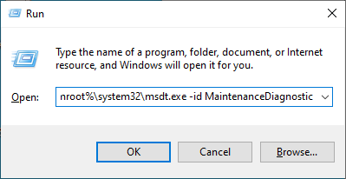

* 1. Once the System Maintenance opens, note the message that the MSDT and its Troubleshooters are being (or have been) retired (Win 11 Ver 23H2 and after).

|  |
| --- |
| 1. Research online and report below what Troubleshooting is being replaced with. The Get Help app is replacing the outdated Microsoft Support Diagnostic Tool (MSDT) and its integrated troubleshooters in Windows 11 version 23H2 and later. 2. How do you access the replacement system? In Windows 11, the Get Help app can be found through the Settings app or by searching for it in the Windows search bar. Click "Open" to start the program after typing "Get Help" into the search bar. As an alternative, it can be located Get Help by going to Settings > System > Troubleshooting > Other troubleshooters. |

1. Check Event Logs

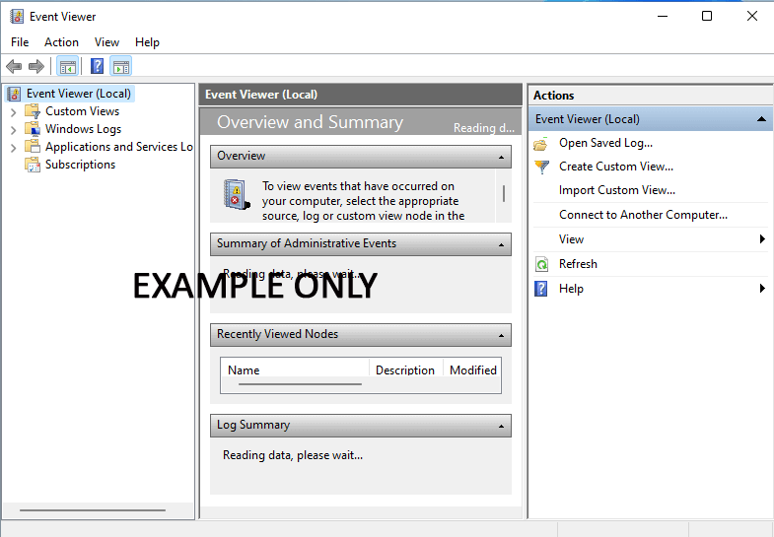

* 1. Examine logs for errors or problems.
  2. Lookup three entries (either errors or warnings) on Microsoft’s website

|  |
| --- |
| Insert **Snips 8, 9 & 10** for each error |

* 1. Clear all existing log entries.

1. Open ***Disk Cleanup*** from the ***Start Menu*** and run it. Do not change the default selection but note what other files can be removed. Use the ***System files*** button. Investigate the ***More Options*** tab

|  |
| --- |
| How much total disk space can you gain from just the default cleanup? …..  Take **Snip11** showing the Disk Cleanup dialog box and paste here. |

1. Open ***Task Scheduler*** from the ***Windows Tools***.
   1. *Create Basic Task* using the *Disk Cleanup* command ***cleanmgr***, One time, a few minutes in your time so that you can see its operation

|  |
| --- |
| Insert **Snip12** of the scheduled Disk Cleanup task in the ***Task Scheduler*** and paste here. |

**Section 2: Hardware Maintenance**

1. Clear out dust and lint   
   **Optional** if you viewed the lecturer’s demonstration in class.  
   If you own a PC at home you are encouraged to clean and dust your PC.

|  |
| --- |
| Insert a BEFORE photo of your **home PC** with the side panel removed to show the extent of any dust buildup. |

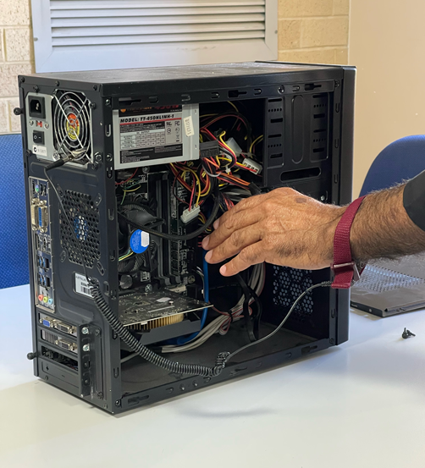

* 1. Wear a dust mask or respirator if you want to avoid breathing in any of the dust and dirt you remove from your case.
  2. Turn off your PC and unplug the power cable from the rear. If you want to be extra safe, unplug everything.
  3. Move your computer outside or to somewhere well-ventilated if possible, or at least open a window or door to let fresh air into the room.
  4. Remove the side panels and (if possible) the front panel of your case.
  5. Remove the graphic card if you have one for separate cleaning. Observe anti-static measures.
  6. Do not use a vacuum cleaner directly inside the interior of your case, as there is a real risk of static dischage damage.
  7. Wipe down non-electronic items with microfibre cloth
  8. Blow dust out with air duster can or specialised blower (see images below)

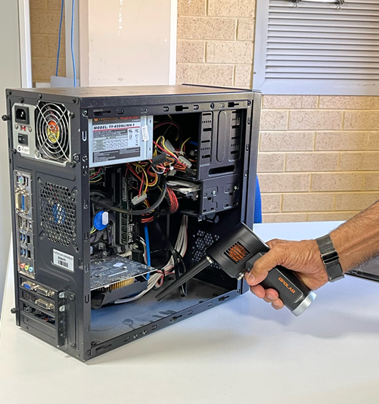 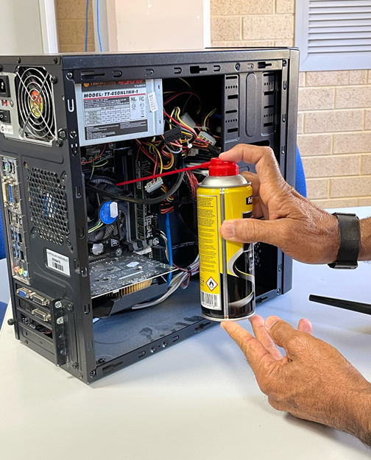

|  |
| --- |
| Insert a Photo of the PC AFTER dusting to the contrast the Before Photo. |

1. Reseat RAM modules and Remove and Replace a Graphics Card. (best done using TAFE’s pull down PCs in class)  
   If instructed by your lecturer, connect the PC box to peripherals to check the RAM cards are installed correctly both before and after these steps.

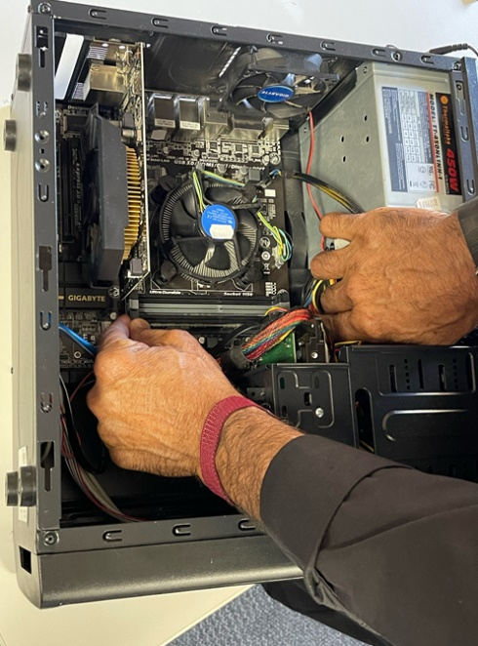 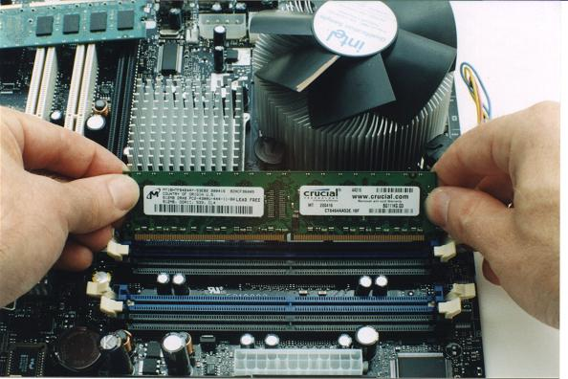

* 1. Check with your lecturer for permission to begin
  2. Turn off your PC and unplug the power cable from the rear.
  3. Ensure that you are statically discharged
  4. Open the case
  5. Remove the Graphics card by removing the securing screw on the case and be sure you have pressed down the release lever at rear of the PCI-Express slot as you remove the card.
  6. Remove the RAM modules – without touching the electrical contacts
  7. Replace the RAM modules back into the correct location
  8. Ensure that the RAM modules are correctly seated
  9. Replace the Graphic card and secure it with the screw.